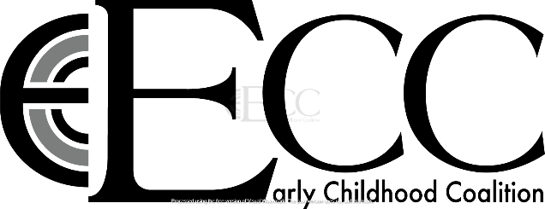

Participant Name: ________________________________________________

Participant Gateway’s #: ________________________________________________

Participant Role: ______________________________________________________________

Person/Agency Requesting Checks Made Payable to: _________________________________________

Address Checks Should be Mailed to: ______________________________________________________

Contact Email: ________________________________________________________________________

I understand that funds will be disbursed in the following months and that if I fail to meet my
commitments as outlined in the program expectations as outlined in the program application I will not
be eligible to receive a stipend.
Initials: ___________

A W-9 must be on submitted with this form for payment to be issued. Payments will be
issued from the Early Childhood Coalition of the Illinois Quad Cities Area. You will be issued a Form
1099 tax document for dollars received in this project and are responsible for reporting funds received
as required for tax purposes. Should the mailing address reporting above change during this project it
will be your responsibility to inform a representative of the Early Childhood Coalition of the Illinois
Quad Cities Area of this change to ensure payments and tax documents are received.
Initials: ____________

